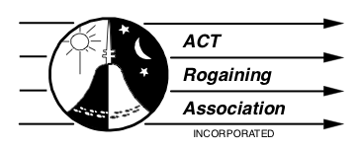

2023 Annual General Meeting
5 March 2023
Hash House Pierce’s Creek approx. 4:20 pm
Please see final instructions for the Paddy Pallin 6 hr rogaine to get to the Hash House. https://act.rogaine.asn.au/events/eventdetail/120/-/paddy-pallin.html

Agenda

- Minutes AGM 2022
- President’s report
- Treasurer’s report and presentation of audited accounts
- Election of office bearers
  - President
  - Vice-President
  - Treasurer
  - Secretary
- Election of committee members
- six to eight people
- Other business

